**AWS :**

**S3 BUCKET POLICY**

Step 1: go to the aws management console and search for S3 .

Step2 : navigate to the s3 dashboard and create a new s3 bucket or can choose an already existing bucket.

Step 3 : To create a new s3 bucket ,click on ‘create bucket’.then name a bucket globally unique and select the region.keep the ACLs disabled.and for now block all public access.bucket versioning is your choice to make it enable or disable.here we kept it disable.leave all the advanced settings by default ,including encryption settings.then click on create bucket.

Step 4: after creating the bucket,click on the bucket and upload any file or document in it.

Step 5 : Now copy the URL of the object that you upload in the bucket.and paste into browser.it will not be accessible because it has no public access .So to assign public access follow the following steps.

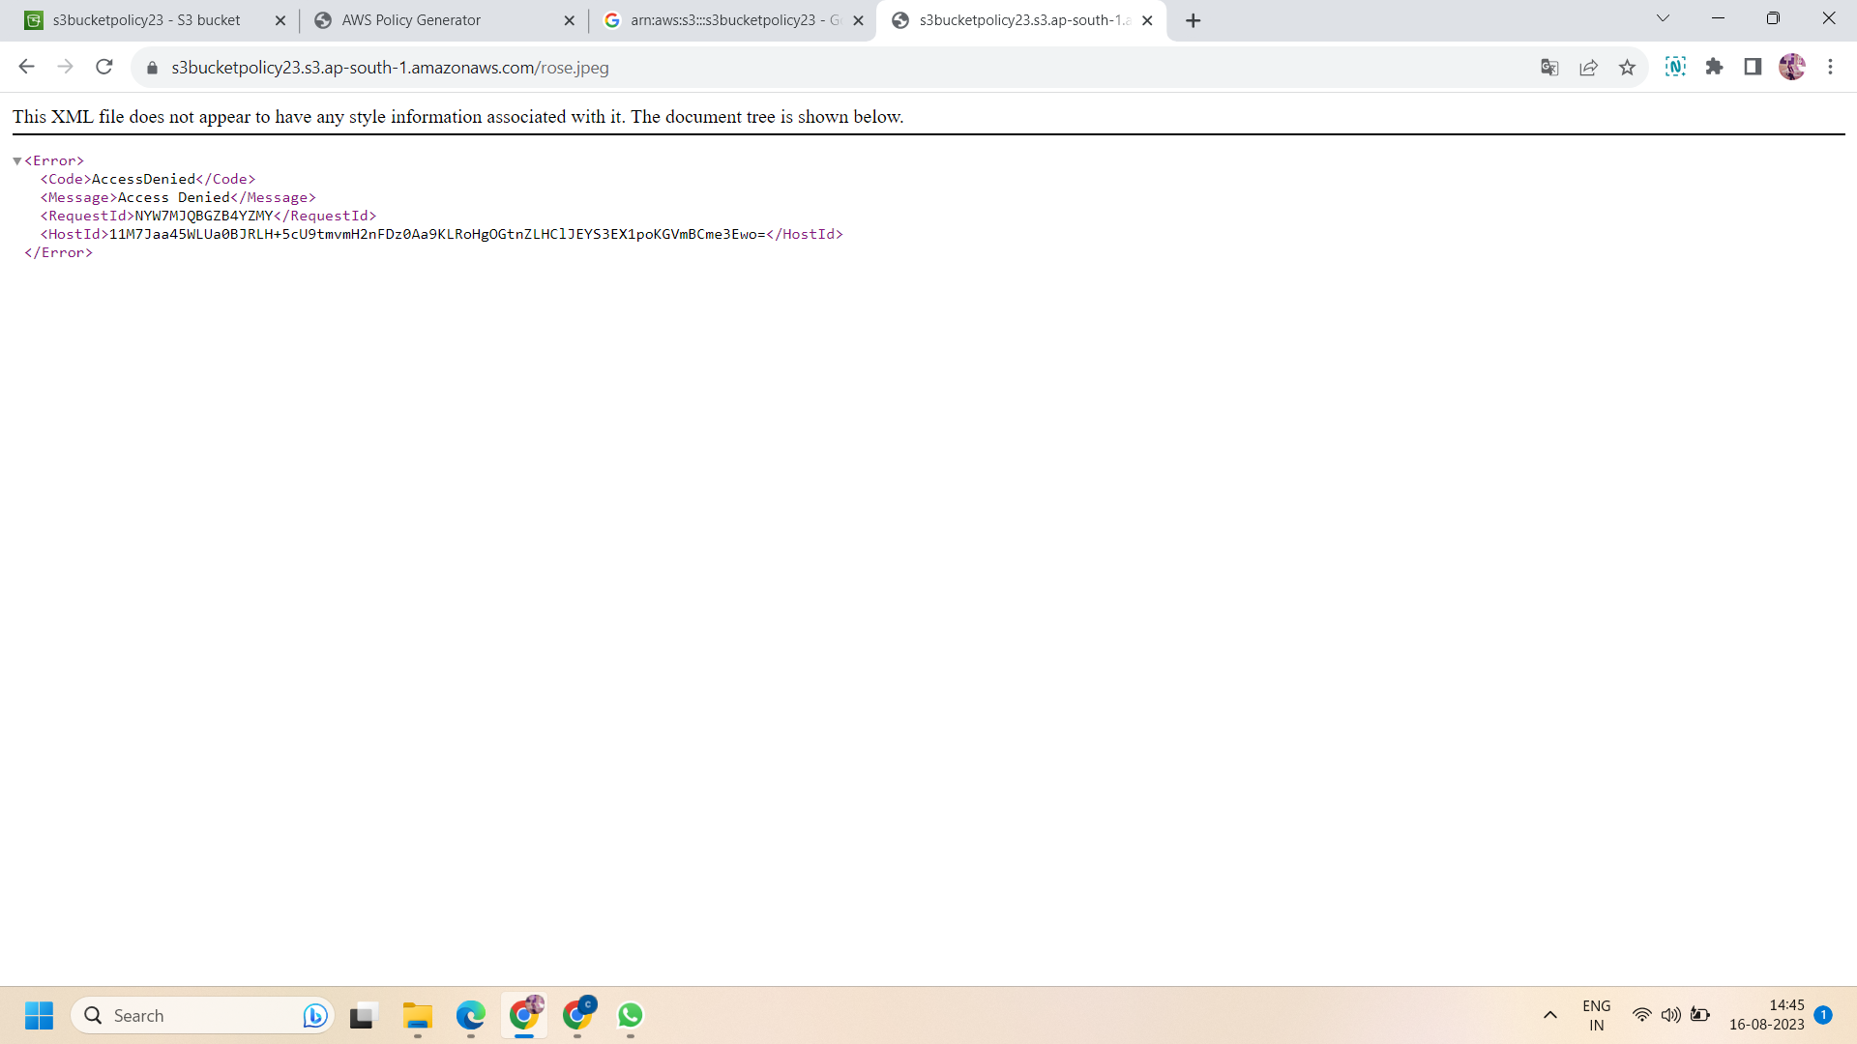

Step 6: Then click on “permissions” in the bucket and edit the block public access.

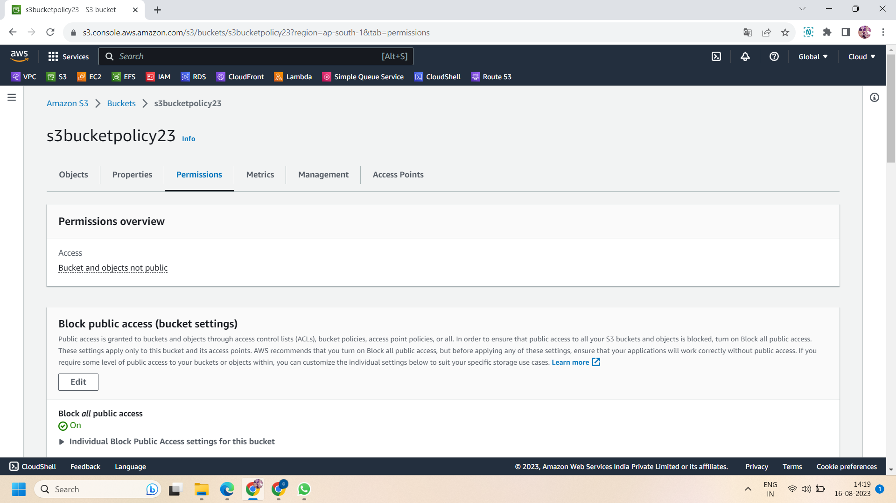

Step 6: after editing the bucket settings,uncheck or turn off the block all public access.this make your file publicly accessible.then save changes.

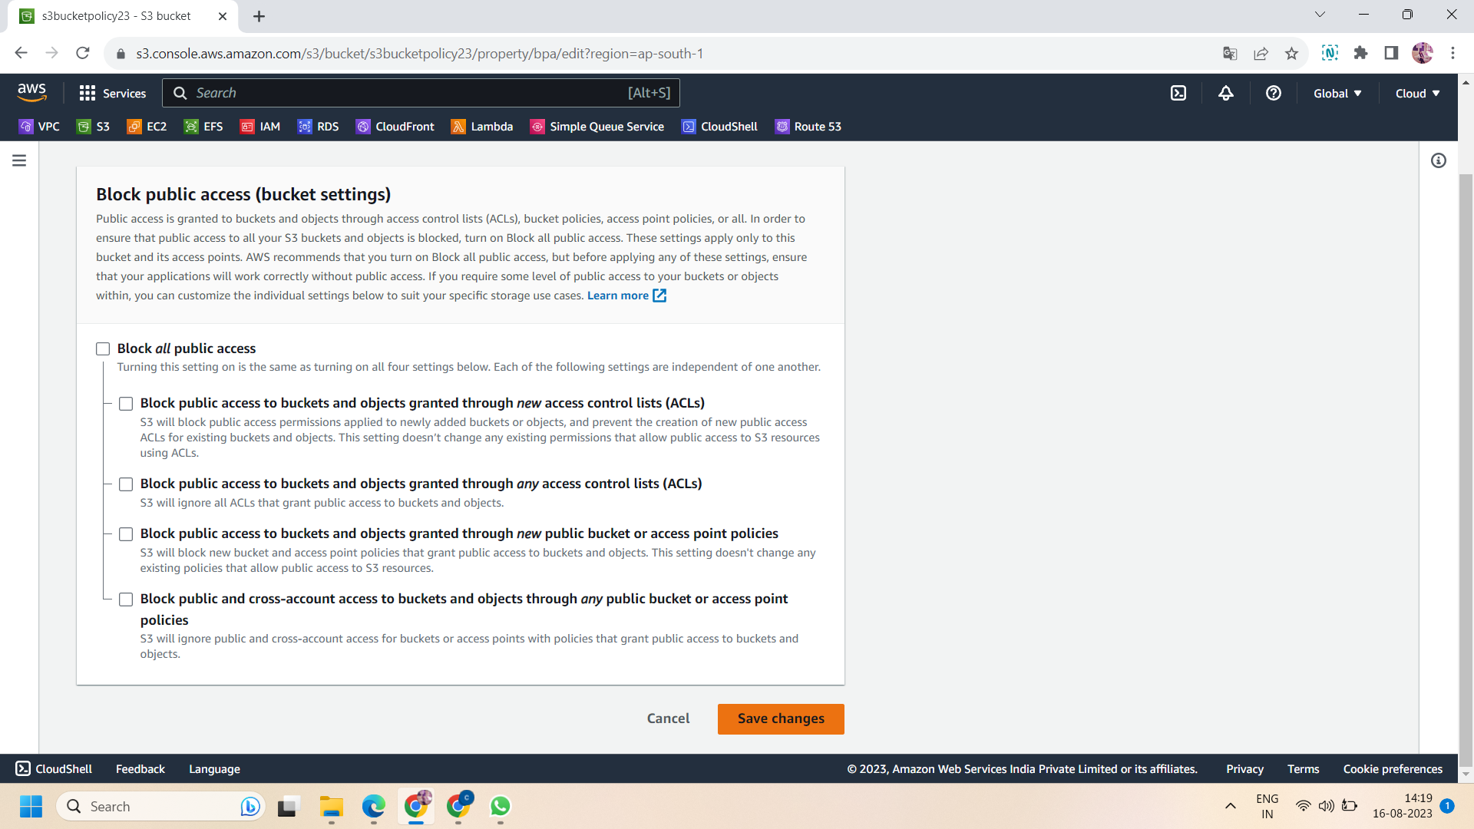

Step 7: After turning off the block public access then move to “bucket policy” that will be below block public access settings.and then click on policy generator to create a new policy ,or if you already have a policy then you can use that one also.

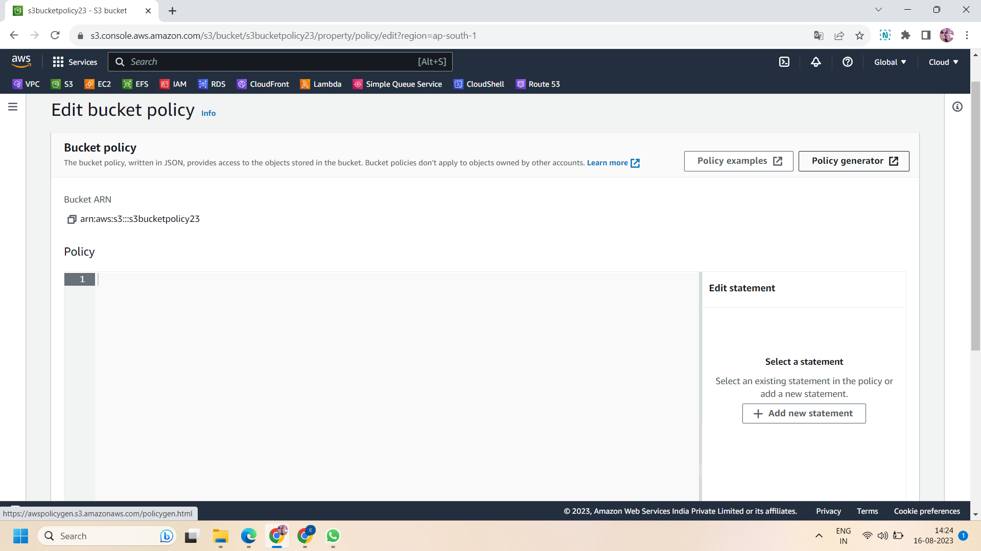

Step 8: then select the actions and principal according to your requirements .firstly choose the policy type ,here we choose “S3 bucket policy” then effect will be “allow” and principal will be “*” ,select the action ,here we only need to read objects so we select the one action only that is “GetObject” and then paste the arn of your s3 bucket in arn section then click on “add statement” .after that click on “generate Policy” .

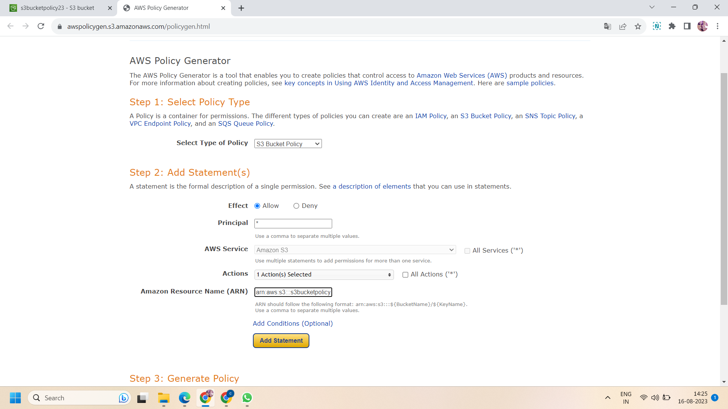

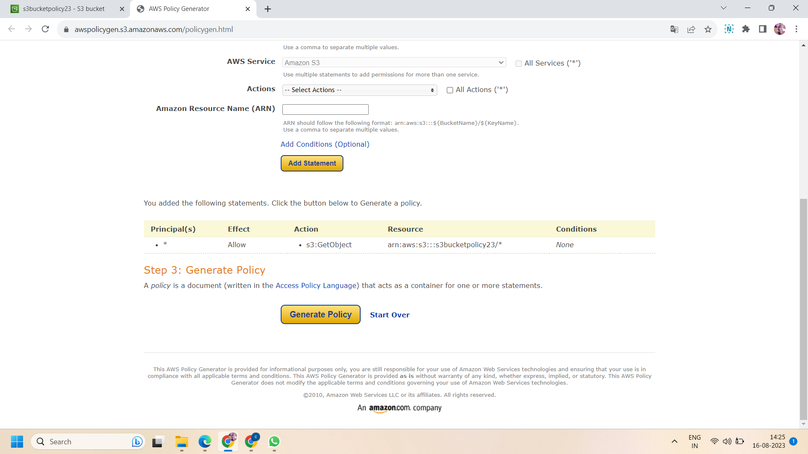

Step 9: then copy the policy and paste into your bucket policy and save changes .This makes your object inside file public.

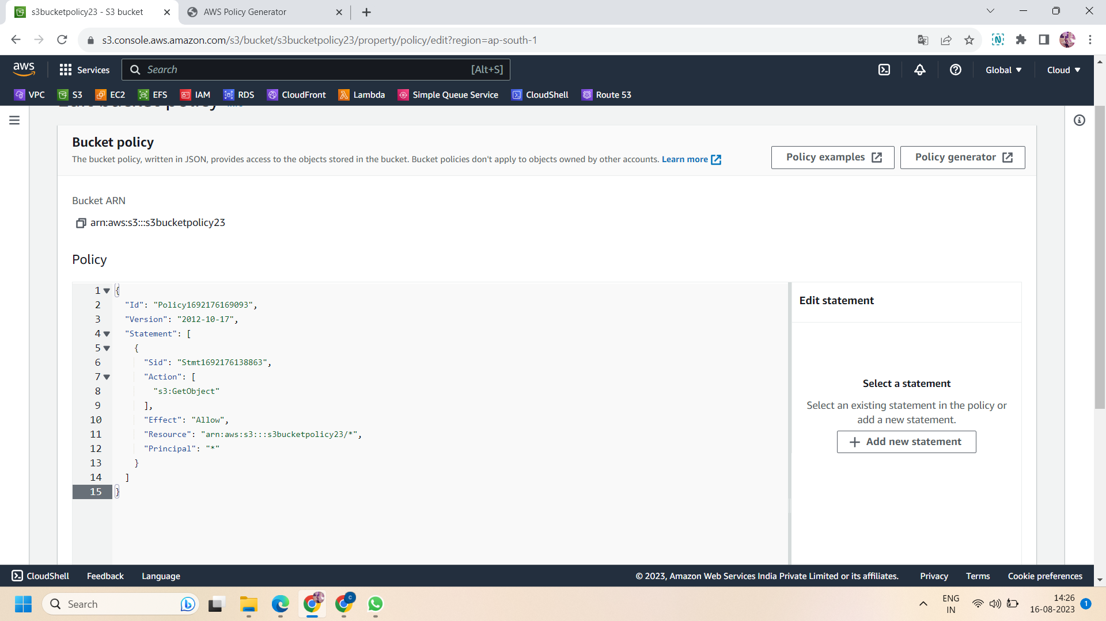

Step 10: After performing the above action ,the status of permission overview is now “public” .This means now every object of the bucket can be accessed publicly.

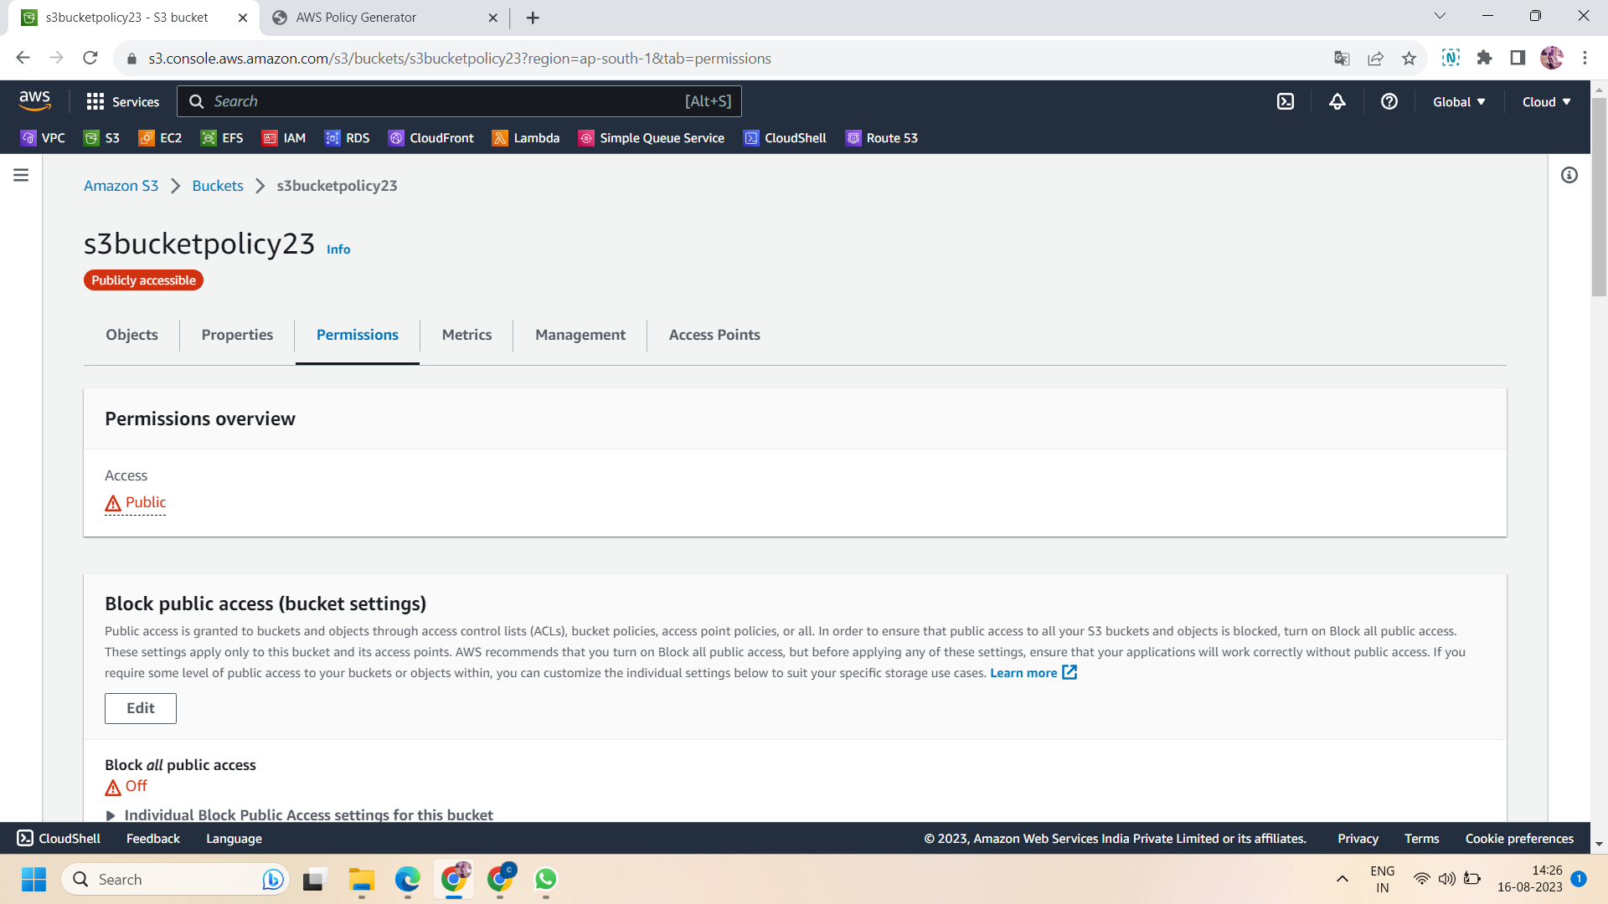

Step 11 :Now copy the URL of the object that you upload inside bucket and paste into browser .It will be visible but before adding the bucket policy if you try to access it ,it will show you error of permission denied.here we uploaded the image file into bucket so we get it like this.

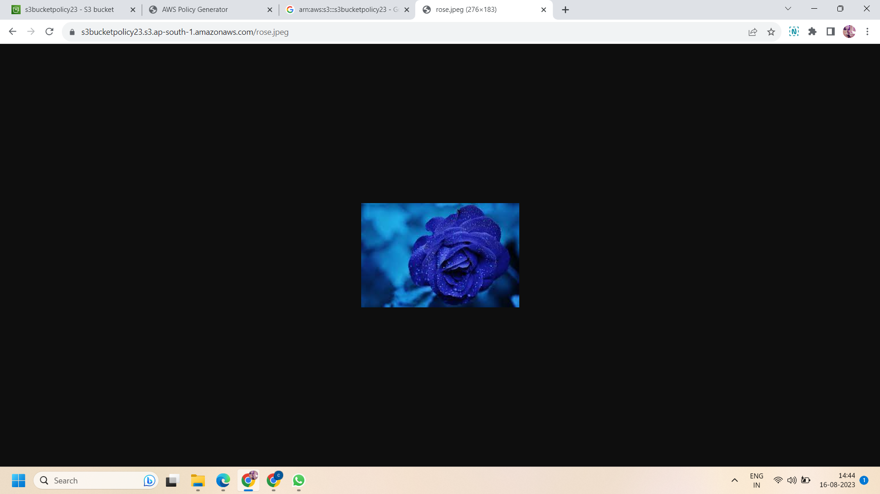

Successfully done!!